Air Ticket Information

AIM : Create html web page for Air ticket reservation

• Make use of marquee tag( to scroll vertically up), image tag, table and

link tag for designing your web page.

• Mention the flight number, name , departure and arrival details of all

flights inside a table. (minimum 10 trains)

• When user clicks on particular train, he/she should be able to see list of

all stops with timings details.

• You can also make use of Text formatting tags.

• Add a food delivery webpage in aeroplane info and connect to Air

ticket information system.

HTML TAGS USED IN THIS WEB PAGE :

* <head> - Heading content of the html file
* <body> - Body content of the html file
* <link> - To link CSS file
* <nav> - Navigation tag to place nav bar options
* <div> - To create a division like a separate container
* <img> - To link an image into the website
* <hx> - heading tag followed by a number noting its size
* <p> - Paragraph tag for text
* <ul> - Un-ordered list
* <a> - Attribute link tag
* <marquee> - marquee tag is used to make scrolling test
* <table> - To Create tables in html
* <tr> - Table Row
* <td> - Table Data of the row
* <th> - Heading of table row
* <strong> - To Make strong-bold text
* <details> - To create a button like thing to show description
* <summary> - To Display a summary for details tag

HTML CODE FOR MAIN WEB PAGE :

<!DOCTYPE html>

<html lang="en">

<head>

<meta charset="UTF-8">

<meta http-equiv="X-UA-Compatible" content="IE=edge">

<meta name="viewport" content="width=device-width, initial-scale=1.0">

<title>AIRLINES Information</title>

<link rel="stylesheet" href="styles.css">

</head>

<body>

<nav class="navbar">

<div class="container">

<img src="logo.png" style="width: 80%;">

<h1 class="logo">QT</h1>

<ul class="nav">

<li><a href="#home">Home</a></li>

<li><a href="food.html">Order Food</a></li>

<li><a href="#About">About</a></li>

</ul>

<ul class="nav">

<li><a href="#home">Log-in</a></li>

</ul>

</div>

</nav> <br><br>

<marquee behavior="" direction=""><h1>----Available flights----</h1></marquee>

<table>

<tr>

<th><strong>FLIGHT NAME</strong></th>

<th><strong>FLIGHT NUMBER</strong></th>

<th><strong>STARTS FROM</strong></th>

<th><strong>DESTINATION</strong></th>

<th><strong>DEPARTURE</strong></th>

<th><strong>ARRIVAL</strong></th>

</tr>

<tr>

<td><details><summary> SPICEJET</summary>

<p>Flight stops</p>

<table style="width:50%">

<tr>

<th>AIRPORT</th>

<th>LAY OVER</th>

</tr>

<tr>

<td>HYDERABAD</td>

<td>5m</td>

</tr>

<tr>

</table></details> </td>

<td>21120</td>

<td>VISAKHAPATNAM</td>

<td>CHENNAI</td>

<td>06:00 AM</td>

<td>15:30 PM</td>

</tr>

<tr>

<td><details><summary>Indigo</summary>

<p>Flight stops</p>

<table style="width:50%">

<tr>

<th>AIRPORT</th>

<th>LAY OVER</th>

</tr>

<tr>

<td>VISAKHAPATNAM</td>

<td>10m</td>

</tr>

<tr>

<td>KOLKATA</td>

<td>25m</td>

</tr>

</table></details></td>

<td>21121</td>

<td>BANGALORE</td>

<td>VISHAKAPATNAM</td>

<td>06:30 AM</td>

<td>12:15 PM</td>

</tr>

<tr>

<td><details><summary>Ethiad</summary>

<p>Flight stops</p>

<table style="width:50%">

<tr>

<th>AIRPORT</th>

<th>LAY OVER</th>

</tr>

<tr>

<td>KOLKATA</td>

<td>30m</td>

</tr>

<tr>

<td>JAIPUR</td>

<td>15m</td>

</tr>

</table></details> </td>

<td>21122</td>

<td>VISAKHAPATNAM</td>

<td>USA</td>

<td>08:25 AM</td>

<td>24:10 PM</td>

</tr>

<tr>

<td><details><summary>Lufthansa</summary>

<p>Flight stops</p>

<table style="width:50%">

<tr>

<th>AIRPORT</th>

<th>LAY OVER</th>

</tr>

<tr>

<td>BHUBANESWAR</td>

<td>40m</td>

</tr>

<tr>

<td>JAIPUR</td>

<td>25m</td>

</tr>

<tr>

<td>KASHMIR</td>

<td>18m</td>

</tr>

</table>

</details> </td>

<td>21123</td>

<td>BANGLORE</td>

<td>QATAR</td>

<td>09:05 AM</td>

<td>23:30 PM</td>

</tr>

<tr>

<td><details><summary>Air india</summary>

<p>Flight stops</p>

<table style="width:50%">

<tr>

<th>AIRPORT</th>

<th>LAY OVER</th>

</tr>

<tr>

<td>BHUBANESWAR</td>

<td>40m</td>

</tr>

<tr>

<td>JAIPUR</td>

<td>25m</td>

</tr>

<tr>

<td>KASHMIR</td>

<td>18m</td>

</tr>

</table></details> </td>

<td>21124</td>

<td>HYDERABAD</td>

<td>JAIPUR</td>

<td>15:00 PM</td>

<td>18:00 PM</td>

</tr>

<tr>

<td><details><summary>Jet airways</summary>

<p>Flight stops</p>

<table style="width:50%">

<tr>

<th>AIRPORT</th>

<th>LAY OVER</th>

</tr>

<tr>

<td>BHUBANESWAR</td>

<td>40m</td>

</tr>

<tr>

<td>JAIPUR</td>

<td>25m</td>

</tr>

<tr>

<td>KASHMIR</td>

<td>18m</td>

</tr>

</table></details> </td>

<td>21125</td>

<td>Delhi</td>

<td>VISAKHAPATNAM</td>

<td>14:00 PM</td>

<td>18:30 PM</td>

</tr>

<tr>

<td><details><summary>AKASA AIR</summary>

<p>Flight stops</p>

<table style="width:50%">

<tr>

<th>AIRPORT</th>

<th>LAY OVER</th>

</tr>

<tr>

<td>BANGALORE</td>

<td>5m</td>

</tr>

<tr>

</table></details> </td>

<td>21126</td>

<td>VISAKHAPATNAM</td>

<td>BOMBAY</td>

<td>18:00 PM</td>

<td>00:45 PM</td>

</tr>

<tr>

<td><details><summary> DELTA AIRLINES</summary>

<p>Flight stops</p>

<table style="width:50%">

<tr>

<th>AIRPORT</th>

<th>LAY OVER</th>

</tr>

<tr>

<td>JAIPUR</td>

<td>45m</td>

</tr>

<tr>

<td>SAN FRANSISCO</td>

<td>25m</td>

</tr>

<tr>

<td>KASHMIR</td>

<td>18m</td>

</tr>

</table></details> </td>

<td>21127</td>

<td>BOMBAY</td>

<td>NEW YORK</td>

<td>11:00 AM</td>

<td>23:00 PM</td>

</tr>

<tr>

<td><details><summary>FLY HIGH</summary>

<p>Flight stops</p>

<table style="width:50%">

<tr>

<th>AIRPORT</th>

<th>LAY OVER</th>

</tr>

<tr>

<td>VISAKHAPATNAM</td>

<td>10m</td>

</tr>

<tr>

<td>CHENNAI</td>

<td>5m</td>

</tr>

</table></details></td>

<td>21128</td>

<td>AMRITSAR</td>

<td>KERALA</td>

<td>19:00 PM</td>

<td>23:45 PM</td>

</tr>

<tr>

<td><details><summary>FRONTIER</summary>

<p>Flight stops</p>

<table style="width:50%">

<tr>

<th>AIRPORT</th>

<th>LAY OVER</th>

</tr>

<tr>

<td>VISAKHAPTNAM</td>

<td>10m</td>

</tr>

<tr>

<td>BOMBAY</td>

<td>25m</td>

</tr>

</table></details></td>

<td>21129</td>

<td>COCHIN</td>

<td>JAIPUR</td>

<td>15:10 PM</td>

<td>23:45 PM</td>

</tr>

</table>

</body>

</html>

CSS CODE FOR Main Site :

body{

background-image: url('indexbg.jpg');

background-color: rgba(0,0,0,0.8);

}

table {

border-collapse: collapse;

width: 100%;

background-color: rgba(0,0,0,0.6);

}

td , th{

border: 1px solid black;

border-collapse: collapse;

text-align: left;

padding: 8px;

}

.navbar a{

color: black;

text-decoration: none;

}

.navbar a:hover{

text-decoration: underline;

cursor: pointer;

text-decoration-color: #fff;

font-size: 104%;

position: static;

}

ul{

list-style: none;

}

.container{

width: 1100px;

margin: auto;

overflow: hidden;

padding: 0 1rem 0;

}

.navbar{

font-size: 1.5rem;

/\* padding-top: 0.6rem;

padding-bottom: 1rem; \*/

background-color: rgba(0,0,0,0.16);

border-bottom-left-radius: 4rem;

border-bottom-right-radius: 4rem;

/\* border: 2rem; \*/

height: 80px;

align-self: center;

justify-content: flex-start;

}

.navbar .container{

display: grid;

grid-template-columns: 0.1fr 0.4fr 1fr 0.3fr;

}

.navbar .container img{

padding-top: 1.8rem;

}

.navbar .nav{

justify-self: flex-start;

display: flex;

justify-content: flex-start;

/\* border-radius: 4rem; \*/

}

.navbar .nav a{

padding: 0 1rem 0;

}

.navbar .nav:hover{

color: antiquewhite;

}

\*{

color: #fff;

}

SCREENSHOTS :

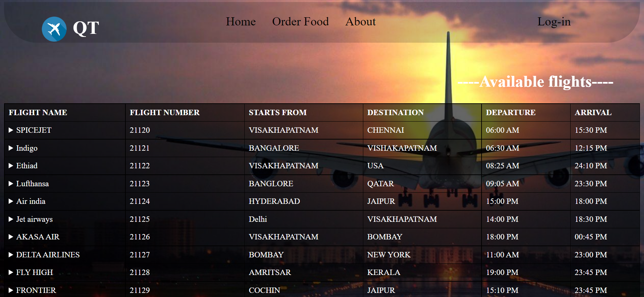

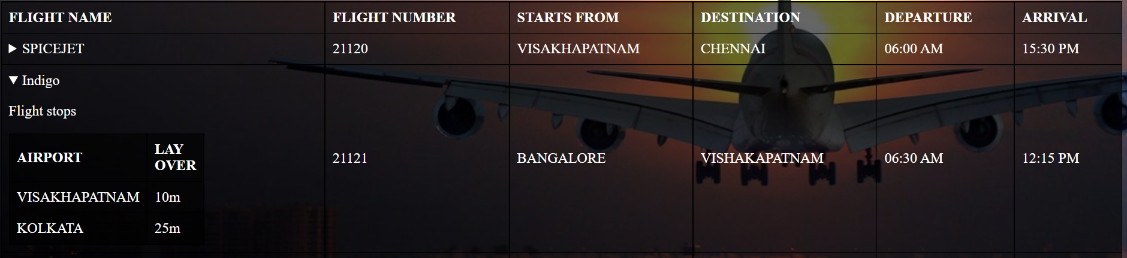

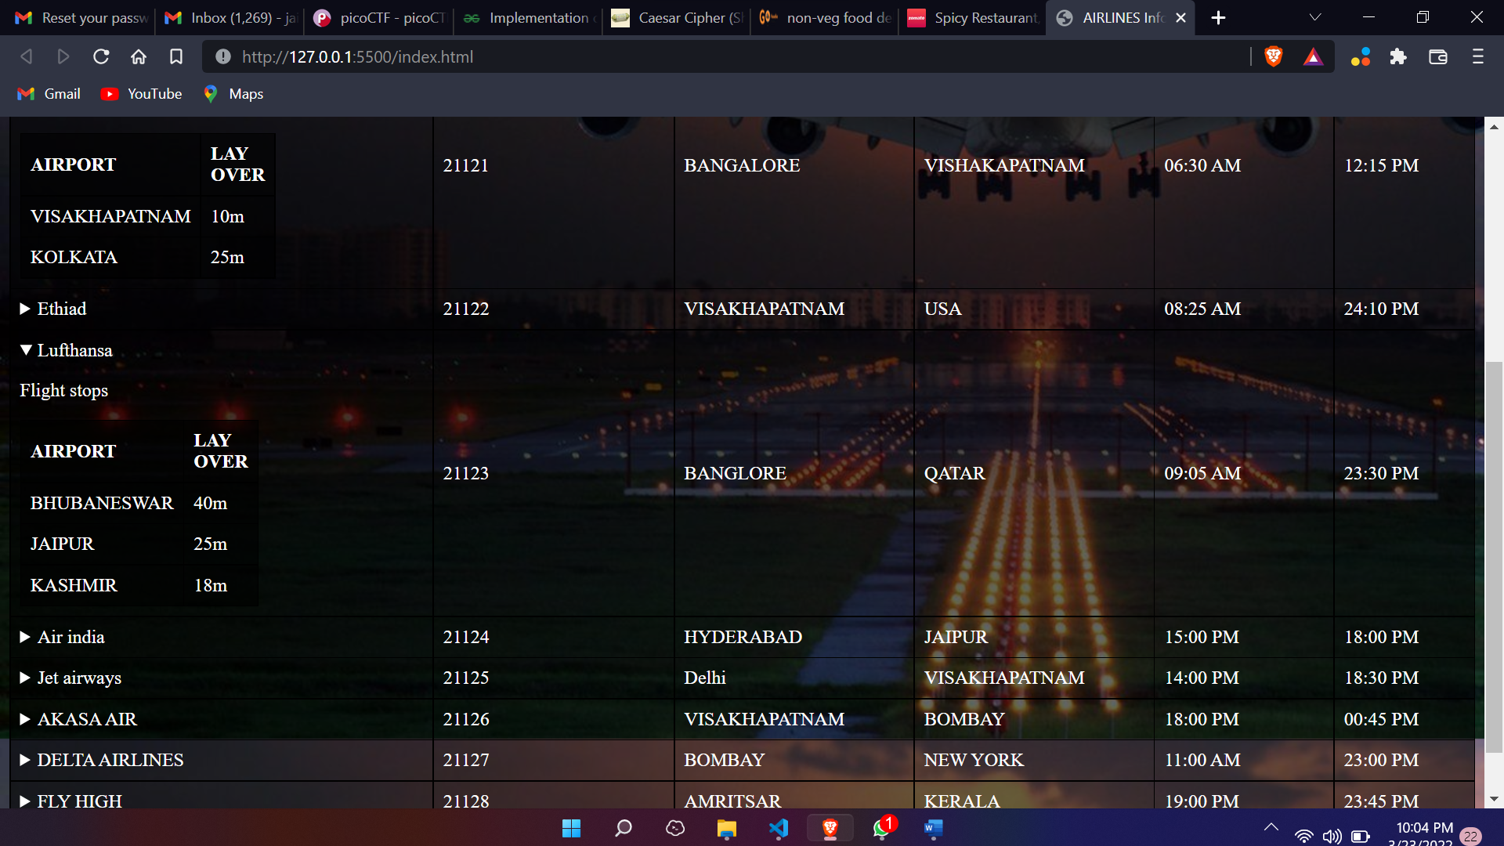

FOOD ORDERING PAGE SOURCE:

<!DOCTYPE html>

<html lang="en">

<head>

<meta charset="UTF-8">

<meta http-equiv="X-UA-Compatible" content="IE=edge">

<meta name="viewport" content="width=device-width, initial-scale=1.0">

<title>Order Your Food</title>

<link rel="stylesheet" href="food.css">

</head>

<body>

<nav class="nav">

<div class="logo">

<img class="logoimage" src="foodlogo.png" alt="logo">

<p class="logotitle">Food in Air</p>

</div>

<div class="nav-options">

<p>Home</p>

<p>About us</p>

<p>Contact us</p>

</div>

</nav>

<div class="MainDescription">

<h1>Food on Air</h1>

<p>

is a trusted online food booking website to order food on

</p>

<h2>We are recognized and certified by Air Amrita</h2>

<p>

This is a most trusted online food delivery in AirWays that allows International flight passengers to online food order in their seats , of their choice from the wide variety of food menu for particular Class while travelling in Air. We have Air food service of meals , Breakfast, lunch, evening snacks, drinks and dinner. Book food & get delivery of desired food in ur seat ie, Jain food, pure veg, non veg food delivery in Air. We believe to serve fresh, quality, hygienic food deliver in a very convenient packaging from best restaurants or hotels, fssai certified at over 280+ Airports internationally for passenger's from our delivery food partners like Air india , spice jet , ethiad , hukyard , etc.

</p>

</div>

<marquee behavior="" direction=""><h1>----Food menu----</h1></marquee>

<div class="Categories">

<a href="#Recommended">Recommended</a>

<a href="#Combos">Combos</a>

<a href="#Signature">Signature dishes</a>

<a href="#Soups">soups</a>

<a href="#Starters">Starters</a>

<a href="#Veg">Veg Main</a>

<a href="#Non-veg">Non veg</a>

<a href="#Drinks">Drinks</a>

</div>

<div class="menu">

<div class="Recommended" id="Recommended">

<div class="ToDos" id="ToDos">

<img src="res/grilled.jpg" alt="">

<span id="title" class="title">

Grilled chicken

</span>

<span id="de" class="de"> £299</span>

<span id="dat" class="dat">Add to cart</span>

</div>

<div class="ToDos" id="ToDos">

<span id="title" class="title">

Item name

</span>

<span id="de" class="de"> <span>Description:</span>

price

</span> <br> <br>

<span id="dat" class="dat"> <span> Deadline: </span>

Add to cart

</span>

</div>

</div>

</div>

<div class="Combos" id="Combos">

<div class="ToDos" id="ToDos">

<img src="res/grilled.jpg" alt="">

<span id="title" class="title">

Grilled chicken

</span>

<span id="de" class="de"> <span>Description:</span>

price

</span> <br> <br>

<span id="dat" class="dat"> <span> Deadline: </span>

Add to cart

</span>

</div>

<div class="ToDos" id="ToDos">

<span id="title" class="title">

Item name

</span>

<span id="de" class="de"> <span>Description:</span>

price

</span> <br> <br>

<span id="dat" class="dat"> <span> Deadline: </span>

Add to cart

</span>

</div>

</div>

</div>

<div class="delivery">

<p>Enter the details to get the delivery</p>

<input type="text" name="" placeholder="Flight number" id="">

<button>submit</button>

</div>

</body>

</html>

SCREENSHOTS :

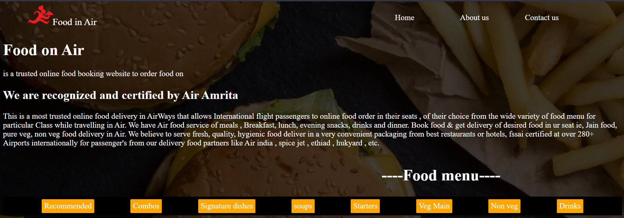

CONCLUSION :

1) We have successfully created a webpage on airticket

system information.

2) By using various html tags which redirected to create

this webpage.

3) Also created a food delivery option for the

passengers those who want to eat the food in our airways.